中南财经政法大学中意学院

**Istituto**

**Italo-Cinese**

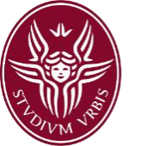

**CERTIFICATION**

This is to certify that , Gender , Date of birth , Student No. , ID Card No. has been studying in The “European Studies: Comparative and European Law” master's degree program in , jointly organized program by Zhongnan University of Economics and Law of Wuhan, China and Sapienza University of Rome, Italy, with 2 years in duration.

Istituto Italo-Cinese

Date: